Abstract

Data Science deals with cleaning, preparation, analysis and visualization of large data. Fetching meaningful information from data

***Guidance: Professor Srikanth***

Data Science Midterm project TEAM 6

Rashmi Yadav Nikita Khamkar Prateek Mane

**West Roxbury**

**Aim: Question 1**

What data mining technique(s) would be appropriate to predict the value of a home in west roxbury? Justify your analysis and model.

**Data set Description:**

File – West Roxbury.xlsx

Features – 14

Records – 5802

Response Variable – Total (Total is the value of a home)

Column name and description –

|  |  |
| --- | --- |
| TOTAL VALUE | Total assessed value for property, in thousands of USD |
| TAX | Tax bill amount based on total assessed value * tax rate |
| LOT SQFT | Total lot size of parcel in square feet |
| YR BUILT | Year property was built |
| GROSS AREA | Gross floor area |
| LIVING AREA | Total living area for residential properties (ft2) |
| FLOORS | Number of floors |
| ROOMS | Total number of rooms |
| BEDROOMS | Total number of bedrooms |
| FULL BATH | Total number of full baths |
| HALF BATH | Total number of half baths |
| KITCHEN | Total number of kitchens |
| FIREPLACE | Total number of fireplaces |
| REMODEL | When house was remodeled (Recent/Old/None) |

**Analysis on Dataset:**

The West Roxbury dataset was analyzed in Tableau.

1. Homes constructed in each year

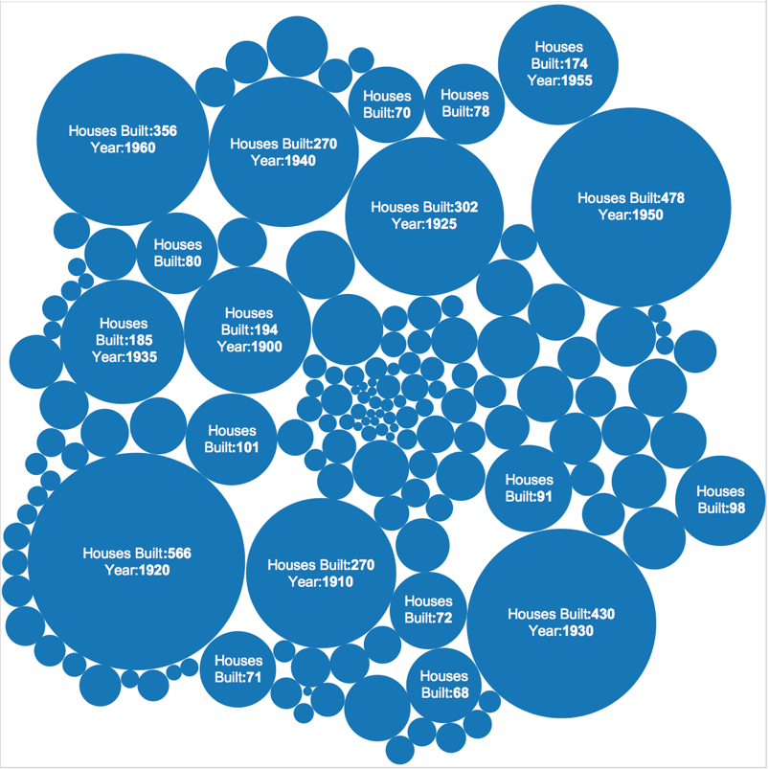

Each circle represents a year and the count of home built in that year. The size of circle depends on the count of homes built.

1. Year-wise impact on home cost based on area

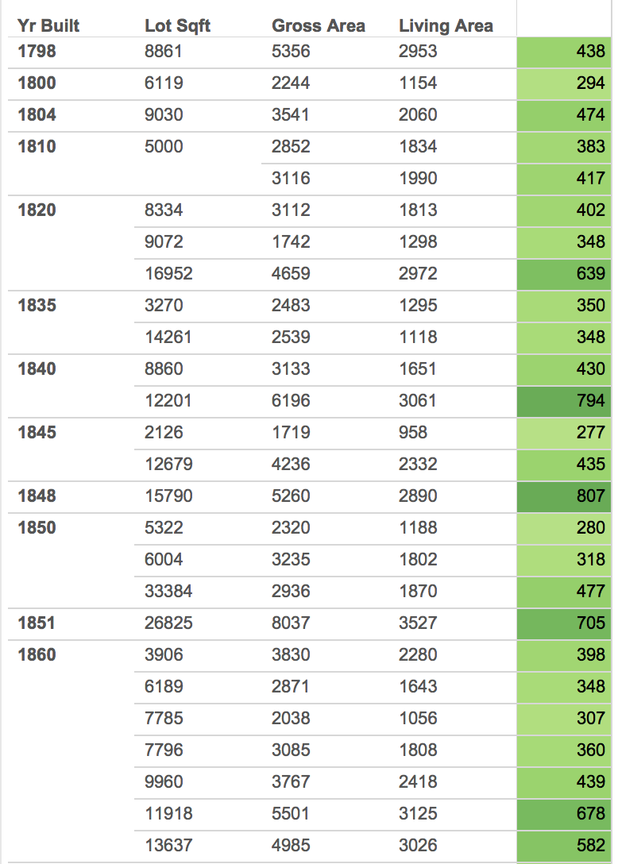

This chart displays how many homes were built in each year, what was the cost of the

House and the living area of the home and total area of the plot.

The value of the home is displayed in green label. The intensity of green color

becomes Dark with the value of home.

Its observed that the Living Area is directly proportional to the value of home.

1. Cost of home with respect to the rooms in the home

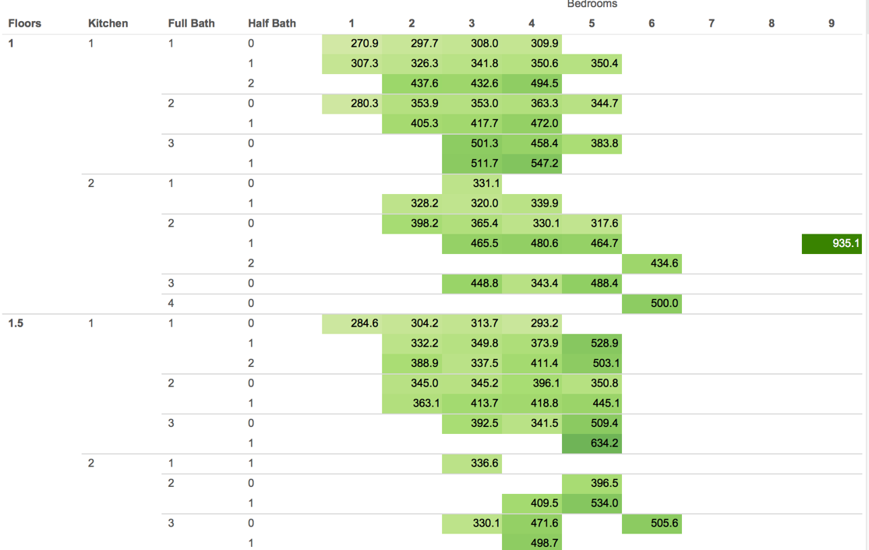

The value of the house is displayed in green label. The intensity of green color becomes Dark with the value of home.

For eg – 935.1K is the value of the home when the home has 1 floor, 2 kitchens,

2 full Baths, 1 half bath and 9 other rooms.

It is observed that the value of home is directly proportional to the number of rooms in the house. If two house have same number of rooms, then the house with more number of half baths has a higher cost.

1. Tax with respect to the area of home

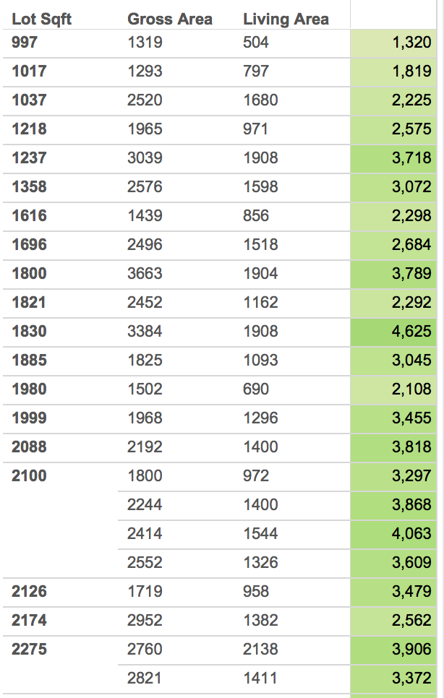

The tax of the house is displayed in green label. The intensity of green color becomes Dark with the area of home.

**Data Transformation**

The remodel column has three categorical values

Values – None, Recent, Old

This column is transformed into a binary column by creating categories.

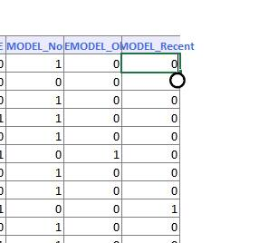

**Correlation Matrix:**

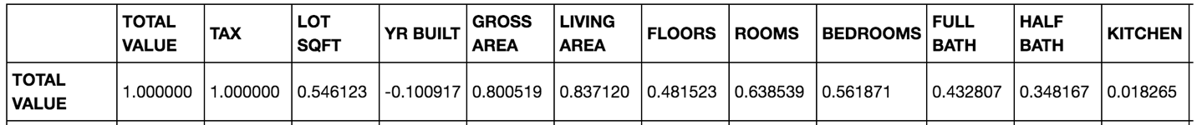

The correlation matrix infers, YR built is weakly correlated with the total value of

Home and TAX is highly correlated with the total value. Hence TAX was dropped from

The dataset.

**Applied Models:**

The data was partitioned in 80(training):20(test)

After the data partition, three models were generated: -

1. CART
2. Random Forest
3. Multi Linear Regression

**Model Evaluation Criteria**

1. RMS error
2. Average Error
3. **CART**

Calculate RMS Error

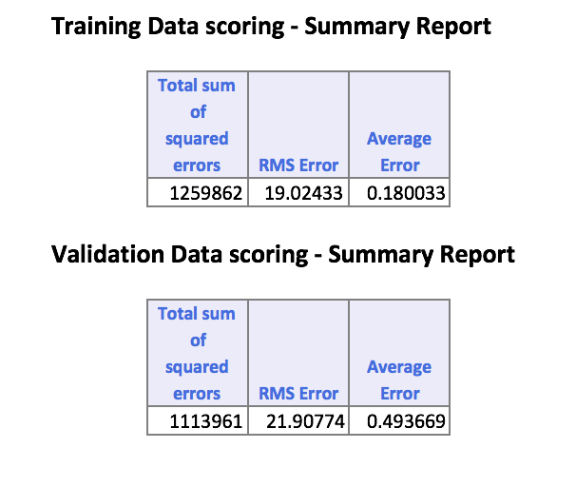

From the table above,

Mean of Total Values column = 400

Standard deviation = 370, 430

RMS error = 21.91

Which lies within the standard deviation range i.e 400 + 21.91 = 421.91

Hence, model built by applying Multi Linear Regression Algorithm over the 80% training and 20% validation data is a valid model.

Decile Chart Analysis

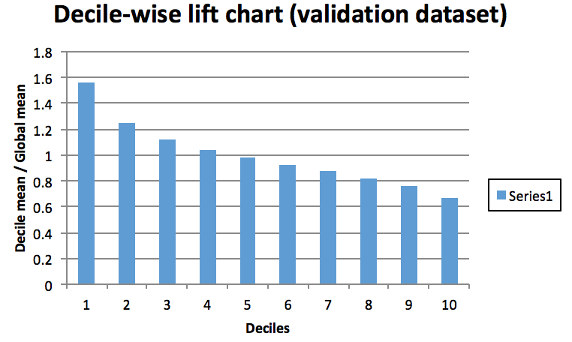

The above decile chart forms a stepwise pattern and hence CART model satisfies the decile chart Evaluation criteria.

The decile-wise lift curve is drawn as the decile number versus the cumulative actual output variable value divided by the decile's mean output variable value. This bars in this chart indicate the factor by which the MLR model outperforms a random assignment, one decile at a time.

1. **Random Forest**

Calculate RMS error

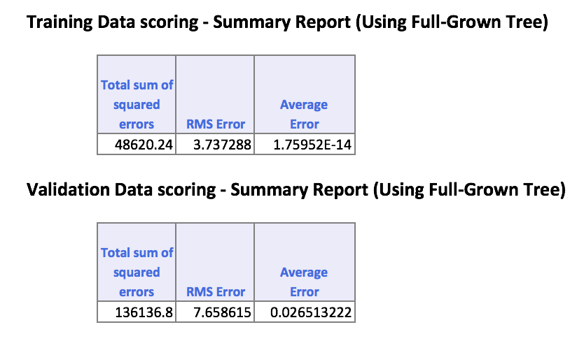

From the table above,

Mean of Total Values column = 400

Standard deviation = 370, 430

RMS error = 7.66

Which lies within the standard deviation range i.e 400 + 7.66 = 407.66

Hence, model built by applying Random Forest Algorithm over the 80% training and 20% validation data is a valid model.

Decile Chart Analysis

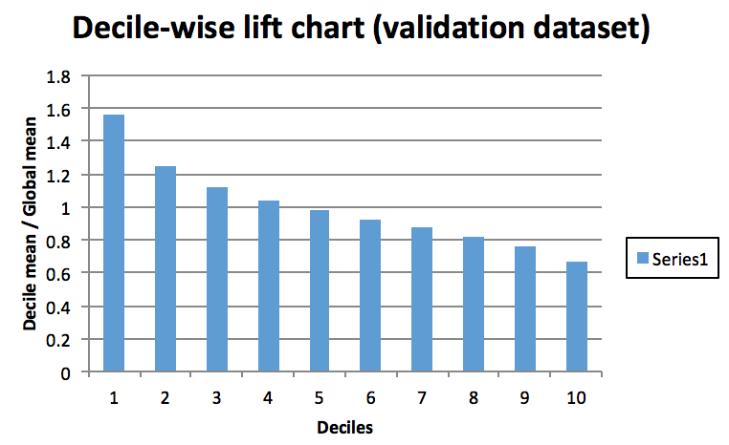

The above decile chart forms a stepwise pattern and hence random forest model satisfies the decile chart evaluation criteria.

1. **Multi linear Regression**

Calculate RMS error

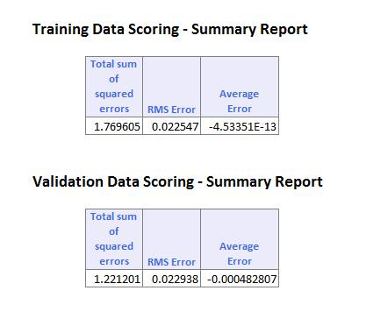

From the table above,

Mean of Total Values column = 400

Standard deviation = 370, 430

RMS error = 0.023

Which lies within the standard deviation range i.e 400 + 0.023 = 400.023

Hence, model built by applying Random Forest Algorithm over the 80% training and 20% validation data is a valid model.

Decile Chart Analysis

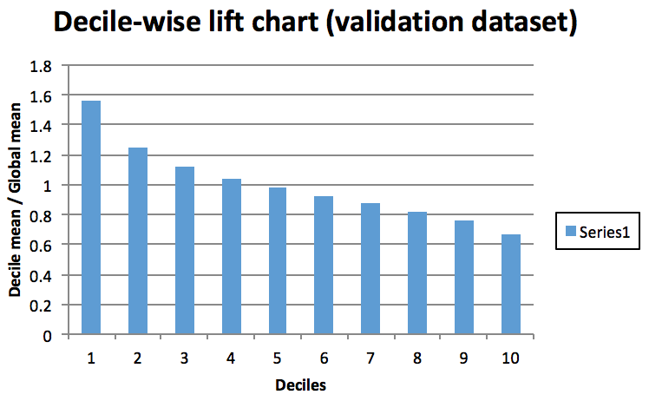

The above decile chart forms a stepwise pattern and hence Multi Linear Regression model satisfies the decile chart evaluation criteria.

**Best Model**

|  |  |  |
| --- | --- | --- |
| **Algorithm** | **RMS Error** | **Average Error** |
| CART | 7.66 | 0.027 |
| Random Forest | 21.91 | 0.49 |
| Multi Linear Regression | 0.023 | -0.0005 |

From the table above, Multi Linear Regression has the lowest RMS Error and Average error. Hence, model built by applying Multi Linear Regression Algorithm over the 80% training and 30% validation data is the best model.

**Model Recommendation & Reasons:**

* Multi Linear Regression is the best model
* The variation in the model is less(based on RMS and average error) and is used to accurately predict the value of home
* Home value depends on all the features except Tax given in the dataset.

**Mortgage Defaulter Prediction**

**Aim: Question 2**

What data mining technique(s) would be appropriate in predicting the defaulter and non-defaulter approved mortgage? Conduct such an analysis.

**Data set Description:**

The Mortgage Defaulter data set contains data on mortgages that have been approved by bank underwriters. It basically contains columns related to the age of the loan borrower, Total loan amount, Ratio of loan to home purchase price, Borrower’s credit score, whether a person is first time home buyer or not, borrowers total monthly debt expense, Borrower's total monthly income, Appraised value of home at origination, Purchase price for house, Tot_monthly_debt_exp/Tot_monthly_income, Current Loan Status that is whether its active, default or paid off, Outcome (either default or non-default), US state in which home is located, Median household income by state 2002-2004, if loan amount is greater than appraisal, Ratio of Loan amt to appraised value of home at origination. The goal is to predict the approved mortgages that may default in future.

**Analysis on Dataset:**

The analysis of the dataset is done in Tableau. So initially we tried finding what attributes are contributing in determining whether a particular approved Mortgage is default or non-default.



In this bar chart we have tried analysis if the outcome is dependent on the average ratio of the loan amount to the estimated present price of the house and average ratio of the purchase price of the house to the estimated present price of the house. What we have observed here is firstly out of the total 15K records 14751 records are non-default and 402 records are default. This implies that the data is biased towards non-default. Herein default and non- default is somewhat dependent upon the ratio of the loan amount to the estimated present price of the house.

We further analyzed the outcome with other attributes like credit score and age of the borrower. Below is the analysis for this.





We can observe here that the outcome (default and non-default) is distributed over the range of age. For age 37 the default number is high as compared to other ages but at the same time the non-default number is also high for the same age. So we cant interpret anything useful from this as age can’t be a factor to determine the outcome of the approved mortgage. Going further we plot the graph between outcome and credit score and see that they are highly related and maximum default observed is for 660.

Next we also compared if the average of loan amount borrowed by borrower and their total monthly debt expense are related for determining the outcome. Here the brown line indicate the average loan amount and red lines indicate the debt expense. So we can see that borrower whose debt expense is high are quite probable to default and also borrower who have taken large loan amount and have credit score in the range of 640 to 680 are likely to default.



Now with these observation we will apply different models on these dataset. But before doing that we have calculated the correlation of outcome with all other attribute. This helped us in deciding which attributes are important.

**Correlation Matrix:**

|  |  |
| --- | --- |
| Input Variable | Correlation |
| Bo_Age | -0.0002233 |
| Ln_Orig | 0.03313622 |
| Orig_LTV_Ratio_Pct | 0.0051409 |
| Credit_score | -0.1113339 |
| Tot_mthly_debt_exp | -0.0406081 |
| Tot_mthly_incm | -0.0215746 |
| orig_apprd_val_amt | -0.0186948 |
| pur_prc_amt | -0.0245268 |
| DTI Ratio | -0.0310822 |
| Median_state_inc | -0.0088064 |
| UPB>Appraisal | 0.0326673 |
| Loan/Estimated Price | 0.03950256 |
| Purchase/present | -0.0208022 |

**Applied Models:**

* **Logistic Regression**
* **Random Forest**
* **Cart**

As we could see in the dataset we had a column called as status (active, default, pay off). Here if the status was pay off it means the borrower has paid the loan amount and its non default. So we removed the number of row where the status was pay-off. So we were left with 8k data. The reason why we removed the pay off data is XLminer restricts the the partition upto 10k data and we had 15k data, and anyhow the pay off data were the borrower who had already paid the loan amount.

So now we ran our algorithm in the 8k resultant dataset

**Model1 - Logistic Regression:**



Here in we can see the coefficient and P-value. here we can see that the P value is greater for credit score and loan amount and subsequently for ratio of LoanAmount/estimatedPriceOfMortgage. Also here we can see the covariance Matrix which speaks about the relation between each attribute with each other.

**Training data confusion matrix:**



Herein we can see none of the default approved mortgage is predicted as in the % error for this is 100% but the overall error is 4.85%, its less because one can run this model and predict the non-default approved mortgage correctly.

And as we run this model on test data we get the below matrix. Which gives 100% for the default approved Mortgage.



Now we try running random forest and cart model on the same dataset and see if there is any difference.

**Model 2 - Random Forest:**

Below is the importance of the attribute in creating the random tree for the dataset. As we can see the most important attribute is loan amount and credit score followed by other attributes.



below is the confusion matrix for the training data. AS we can see as the data is biased this model is good to detect non-default approved mortgage but not for to detect the default approved mortgage. The precision is 0.95 and F1 score is 0.97.



For validating data as well this model is able to predict all the non-default approved mortgage but unable to predict the default approved mortgage.



We will try running the other algorithm to see the pattern that we get there.

**Model 3 - Cart :**

Below is the prior probability of the outcome and we can see the non-default probability is much higher than default. And there are 16 decision nodes.



Now if we see the confusion matrix for the training data we get the below result.



Here out of 316 default approved mortgage only 6 are being detected as default and out of 6304 non-default approved mortgage 6302 are being detected as non-default. So here as well we can see this model is biased towards non-default approved mortgage.



**Conclusion:** So by running all the model in the dataset we couldn’t come up with a correct model as the data is biased and all the model gives an appropriate result for non-default approved mortgage but not for default approved mortgage. So we decided to cut down the data by taking only 1000 non-default data and 402 default data randomly. This makes out dataset unbiased. Now I ran all the three model on the new dataset (1400 records).

**Applied Model on new dataset:**

**Model 1 – Logistic Regression:**

With the 1400 records in the new dataset we partitioned the dataset into 80:20 ratio with 80% training data and 20% validation data. We first ran the logistic regression algorithm. Here we see the P value for different attribute which helps us in doing the feature selection. As from here we concluded that we should remove attribute DTI Ratio, Total monthly Income, Total monthly debt expense.

**Training data confusion matrix:**

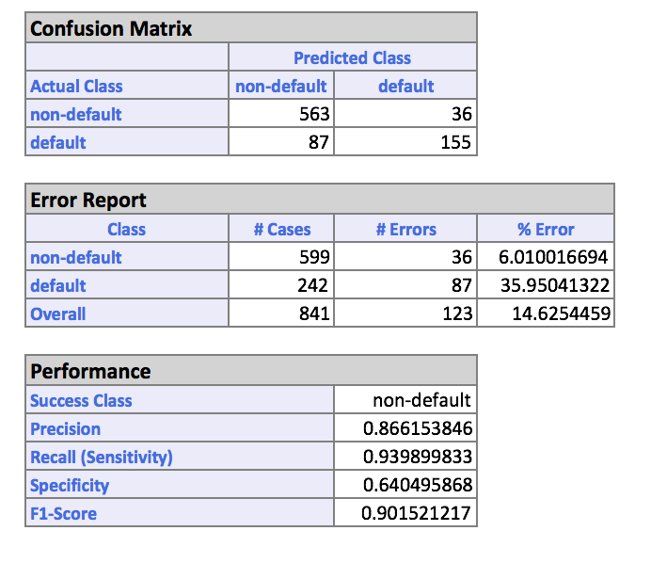

I the above mentioned confusion matrix as we reduced the data to make it unbiased we observe that now out of 242 default approved mortgage 155 are predicted correctly and 87 are predicted wrong and out of 599 non-default approved mortgage 563 non-default are predicted correct. Here the accuracy of the model is 0.90 and precision is 0.86

**Validation data confusion matrix**

Here with the validation data we are getting 60 error for default approved mortgage and 21 error for non-default approved mortgage. We are getting an accuracy of 0.90 and precision of 0.86.

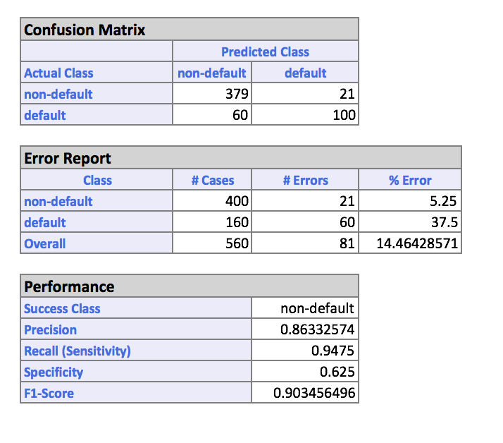

**Training Lift Chart:**

Lift Charts consist of a lift curve and a baseline. After the model is built using the Training Set, the model is used to score on the Training Set and the Validation Set. Then the data set are sorted using the predicted output variable value. After sorting, the actual outcome values of the output variable are cumulated, and the lift curve is drawn as the number of cases (x-axis) versus the cumulated value (y -axis). The baseline (red line connecting the origin to the end point of the blue line) is drawn as the number of cases versus the average of actual output variable values multiplied by the number of cases. The greater the area between the lift curve and the baseline, the better the model.

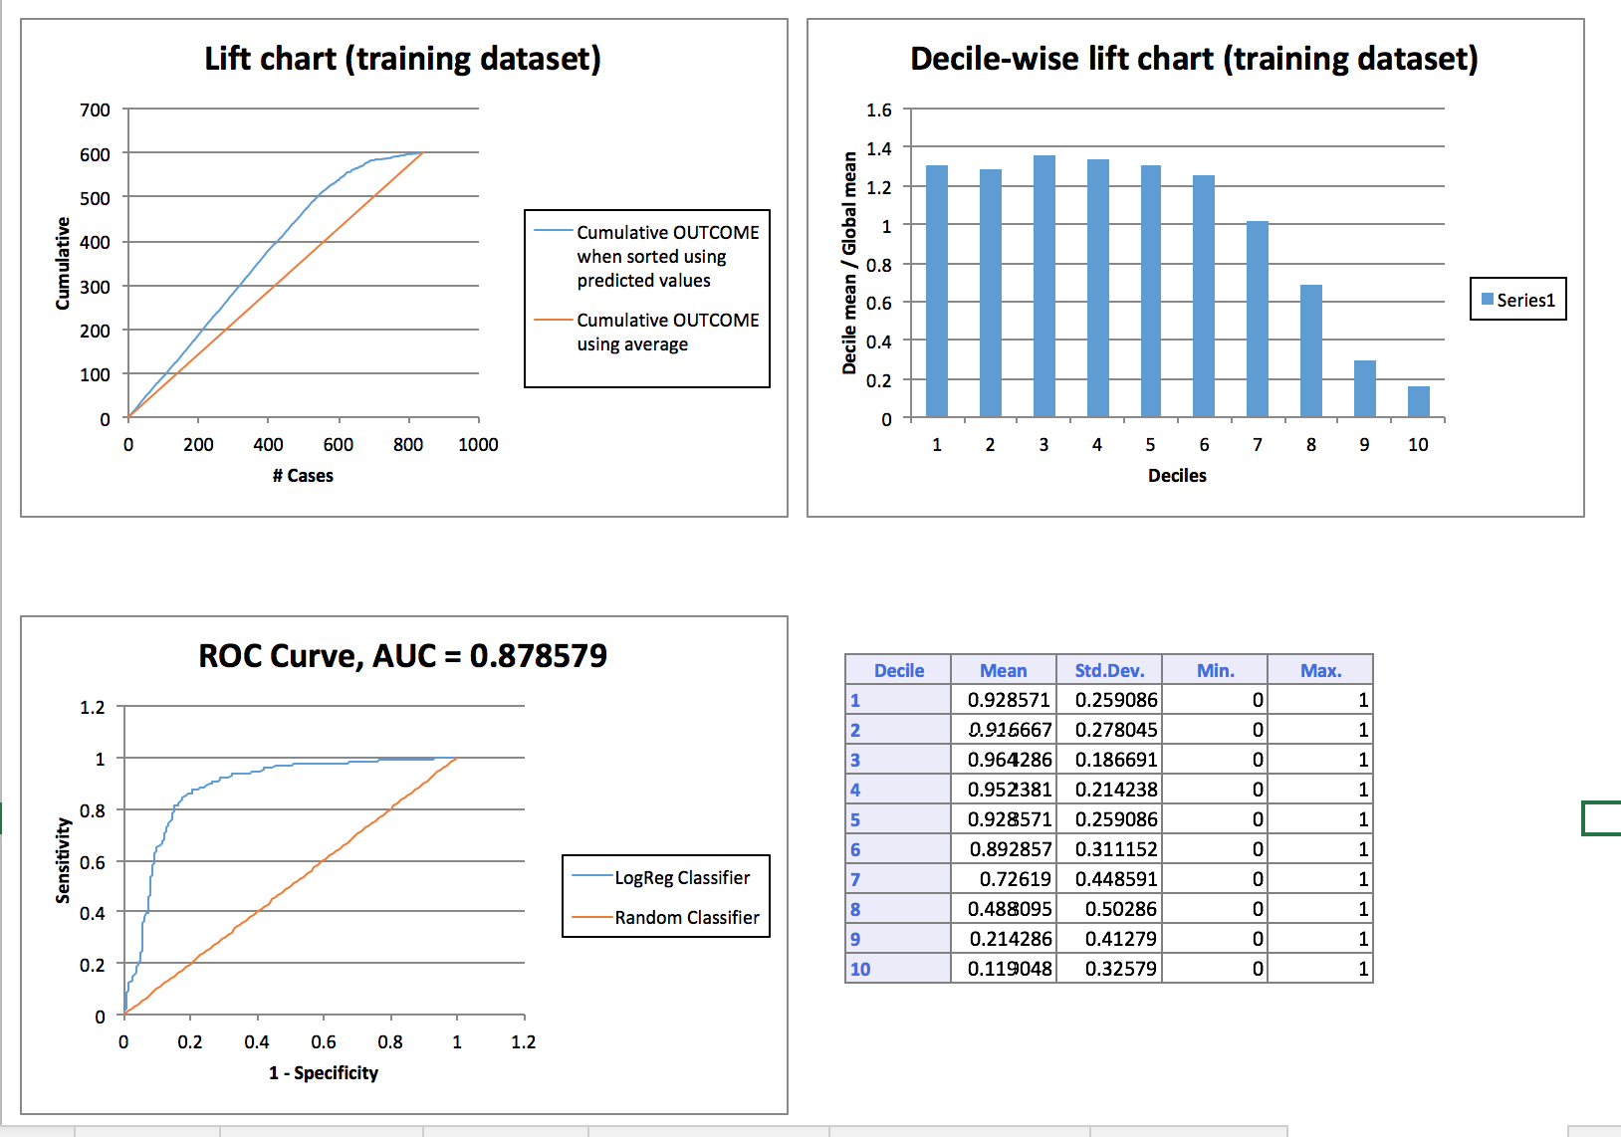

From the lift cart we can observe that in ROC curve we get the AUC=0.87. Also the curve is towards Y axis as expected.

**Validating LiftChart:**

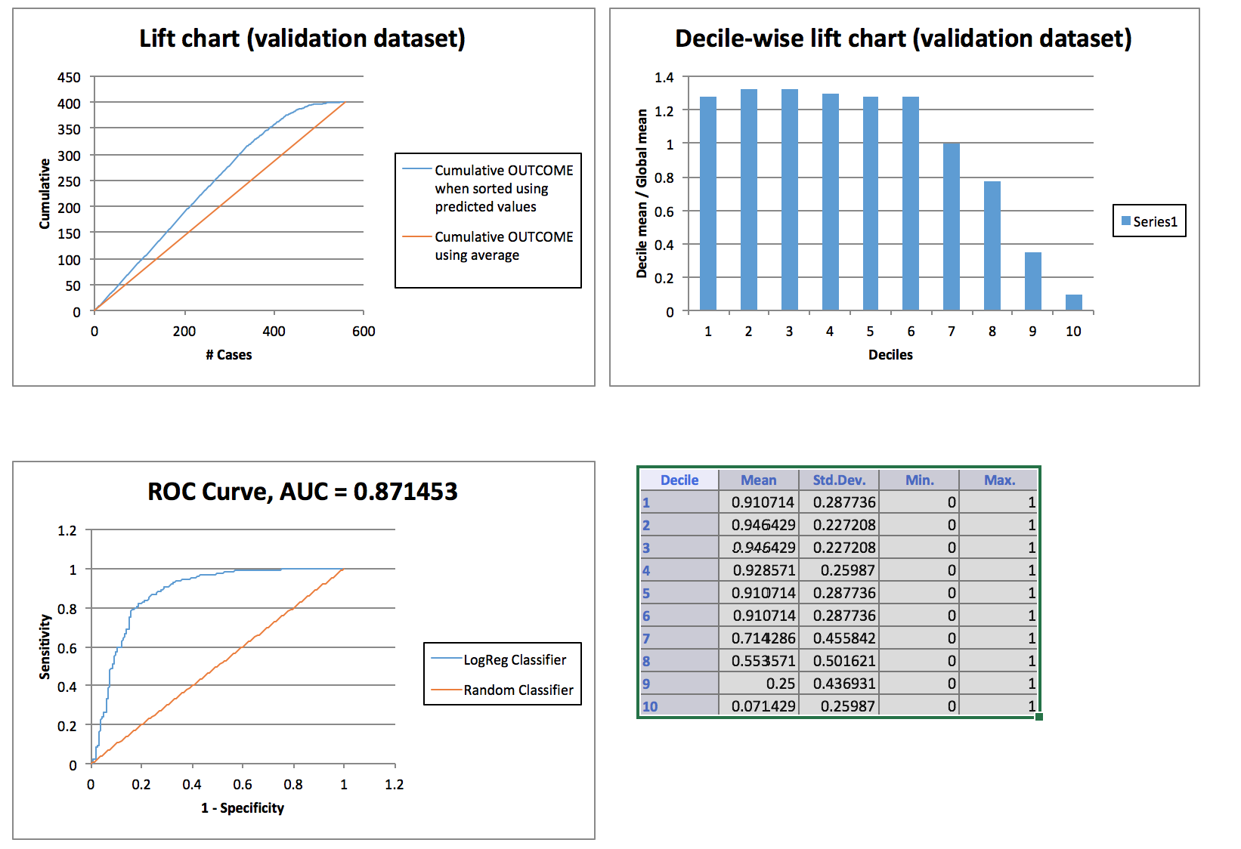

From the lift cart for test data we can observe that in ROC curve we get the AUC=0.87. Also the curve is towards Y axis as expected.

In the Lift Chart (Validating Set) pictured above, the red line originating from the origin and connecting to the point (600, 400) is a reference line that represents the expected number of CAT MEDV predictions if XLMiner simply selected random cases (i.e., no model was used). This reference line provides a yardstick against which the user can compare the model performance. From the Lift Chart below, we can infer that if we assigned 200 cases to class 1, about 150 1s would be included. If 200 cases were selected at random, we could expect about 180 1s.

The decile-wise lift curve is drawn as the decile number versus the cumulative actual output variable value divided by the decile's mean output variable value. This bars in this chart indicate the factor by which the MLR model outperforms a random assignment, one decile at a time.

ROC curves plot the performance of binary classifiers by graphing true positive rates (TPR) versus false positive rates (FPR) as the cutoff value grows from 0 to 1. The closer the curve is to the top-left corner of the graph, and the smaller the area above the curve, the better the performance of the model.

**Model 2 - Cart:**

Here we can see that for cart algorithm the probability for the two classes (default and non-default). In this model 20 decision nodes are taken as we can see for 20 decision node the %error is less.

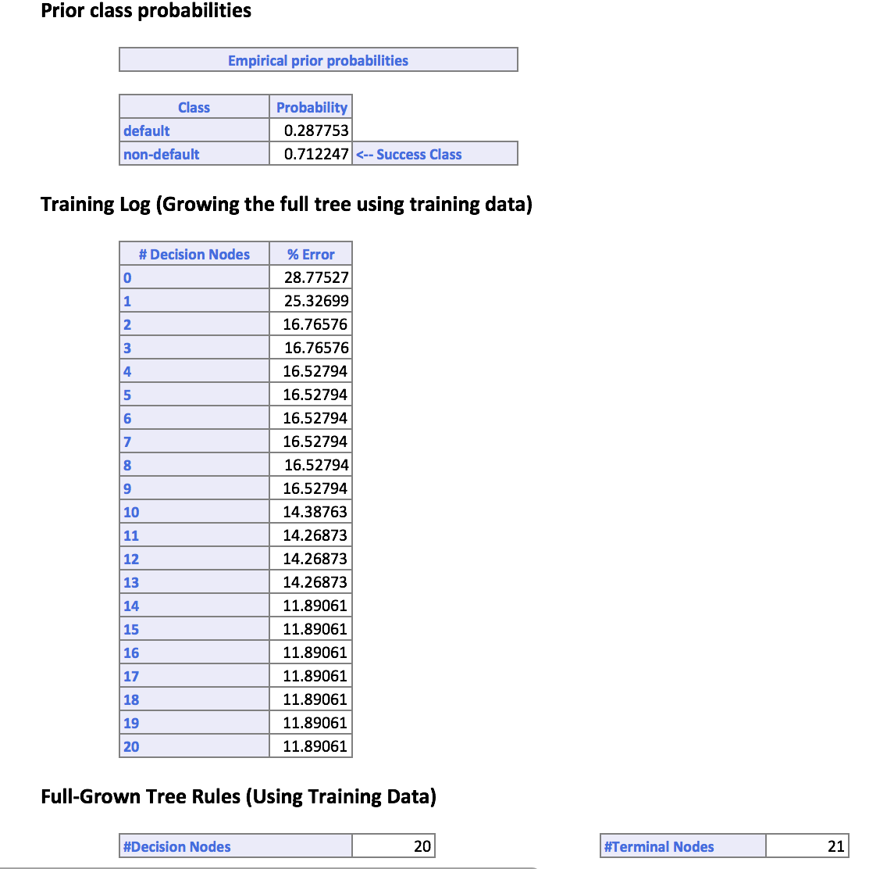

**Training confusion matrix:**

Now we can see that from the below confusion matrix we can see that out of 242 default approved mortgage 161 are correctly predicted and 81 are error while for non-default approved mortgage 580 are correctly predicted and 19 are wrong. The accuracy for this model is 0.92

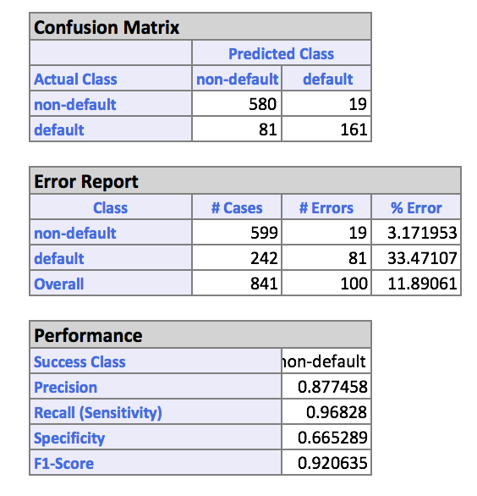

**Validation Confusion matrix:**

Now we can see that from the below confusion matrix we can see that out of 242 default approved mortgage 161 are correctly predicted and 81 are error while for non-default approved mortgage 580 are correctly predicted and 19 are wrong. The accuracy for this model is 0.92

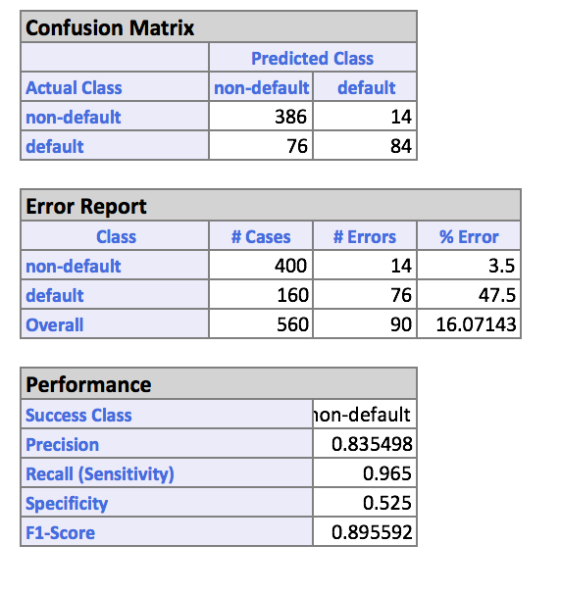

**Training liftchart:**

Here in below chart we can see that in the ROC curve the AUC = 0.92 and also the curve is tilted towards Y axis as expected.

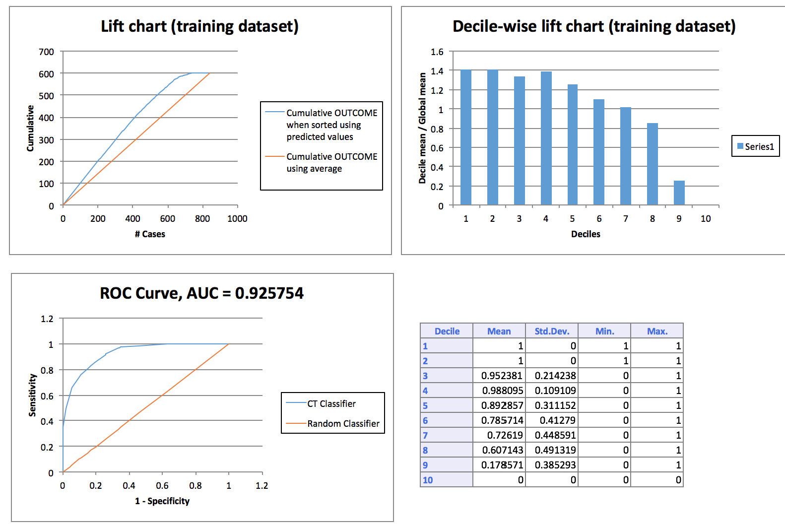

**Validation Liftchart:**

Here in below chart we can see that in the ROC curve the AUC = 0.77 and also the curve is tilted towards Y axis as expected.

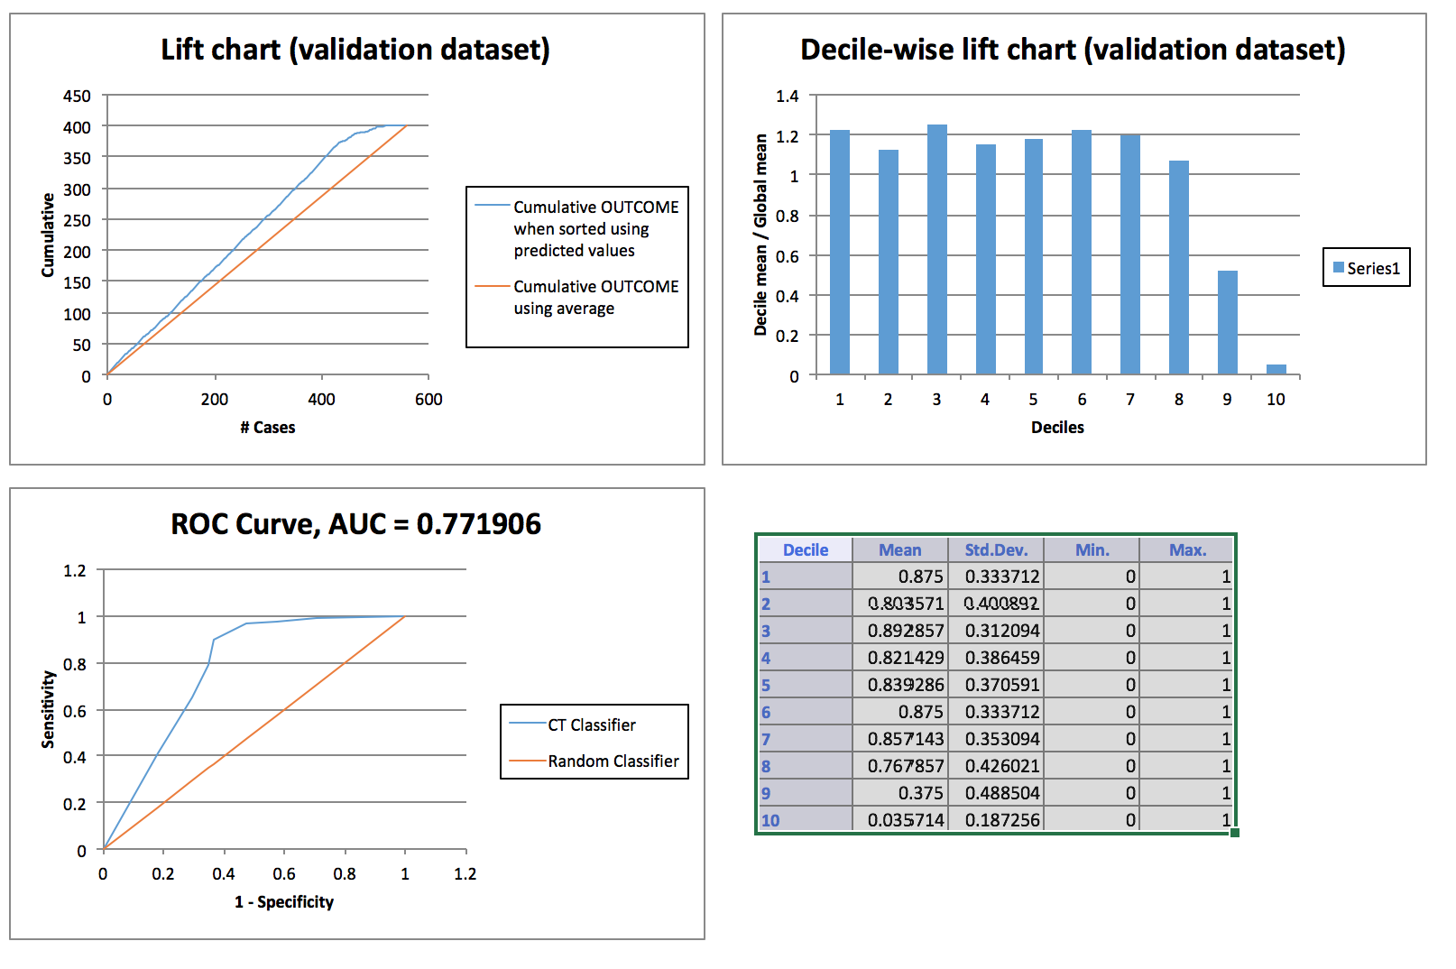

In the Lift Chart (Validating Set) pictured above, the red line originating from the origin and connecting to the point (600, 400) is a reference line that represents the expected number of CAT MEDV predictions if XLMiner simply selected random cases (i.e., no model was used). This reference line provides a yardstick against which the user can compare the model performance. From the Lift Chart below, we can infer that if we assigned 200 cases to class 1, about 150 1s would be included. If 200 cases were selected at random, we could expect about 180 1s.

The decile-wise lift curve is drawn as the decile number versus the cumulative actual output variable value divided by the decile's mean output variable value. This bars in this chart indicate the factor by which the MLR model outperforms a random assignment, one decile at a time.

ROC curves plot the performance of binary classifiers by graphing true positive rates (TPR) versus false positive rates (FPR) as the cutoff value grows from 0 to 1. The closer the curve is to the top-left corner of the graph, and the smaller the area above the curve, the better the performance of the model.

**Model 3 - Random Forest:**

Here we can observe the importance of each attribute, like credit score is the most import attribute. Now with the confusion matrix we get an overall %error as 11.11% and out of 284 default approved mortgage 210 were correctly predicted and 74 was error while for 697 non-default approved predicted mortgage 662 were correctly predicted.

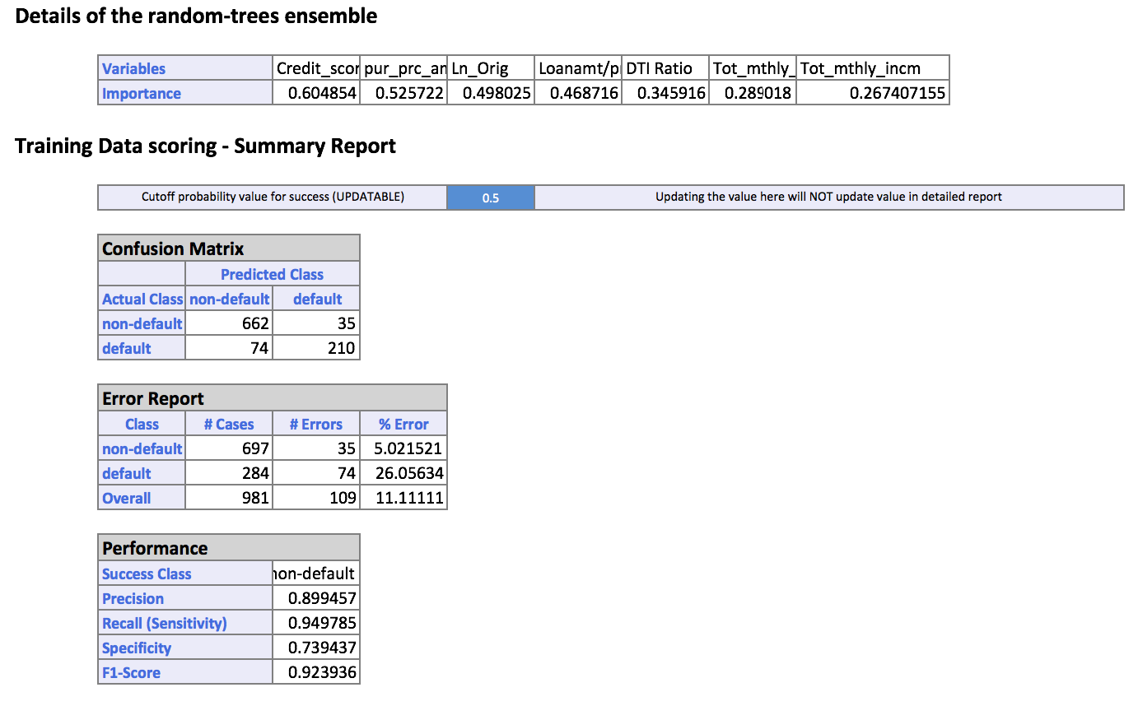

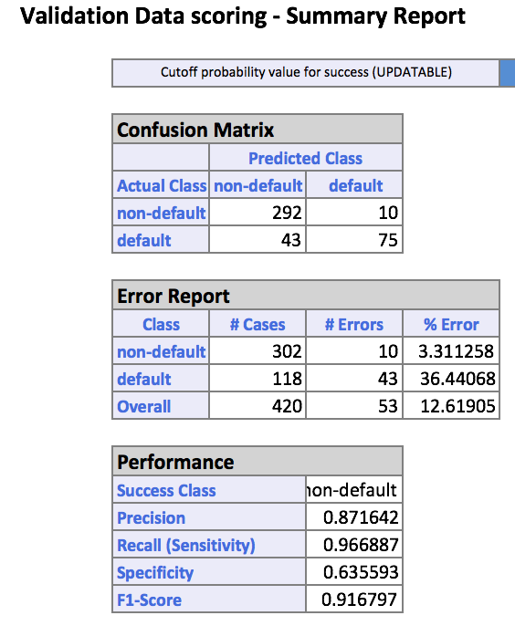

With the confusion matrix we got the accuracy of the model as 0.91 and precision as 0.96

Here in below chart we can see that in the ROC curve the AUC = 0.93 and also the curve is tilted towards Y axis as expected.

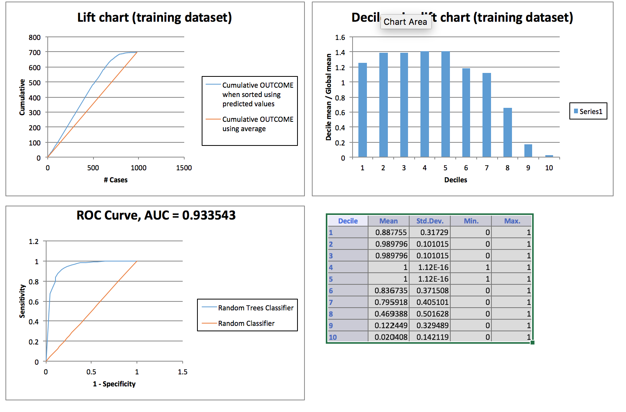

Here in below chart for validation data we can see that in the ROC curve the AUC = 0.86 and also the curve is tilted towards Y axis as expected.

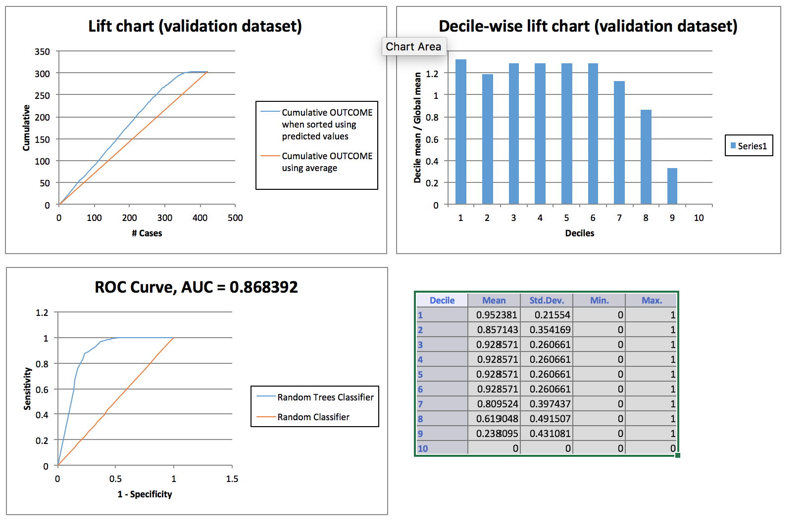

In the Lift Chart (Validating Set) pictured above, the red line originating from the origin and connecting to the point (600, 400) is a reference line that represents the expected number of CAT MEDV predictions if XLMiner simply selected random cases (i.e., no model was used). This reference line provides a yardstick against which the user can compare the model performance. From the Lift Chart below, we can infer that if we assigned 200 cases to class 1, about 150 1s would be included. If 200 cases were selected at random, we could expect about 180 1s.

The decile-wise lift curve is drawn as the decile number versus the cumulative actual output variable value divided by the decile's mean output variable value. This bars in this chart indicate the factor by which the MLR model outperforms a random assignment, one decile at a time.

ROC curves plot the performance of binary classifiers by graphing true positive rates (TPR) versus false positive rates (FPR) as the cutoff value grows from 0 to 1. The closer the curve is to the top-left corner of the graph, and the smaller the area above the curve, the better the performance of the model.

**Model Recommendation & Reasons:**

* Random Forest model works very well compared to Cart and Logistic Regression.
* Also Random Forest Model most stable model amongst three
* Random forest algorithm has the accuracy better than the other two model
* Random forest has less overall % error, which tells that on predicted values random forest has less probability of error
* Not just accuracy of any model is important factor while deciding whether model is good or bad, the stability of model matter’s the most.

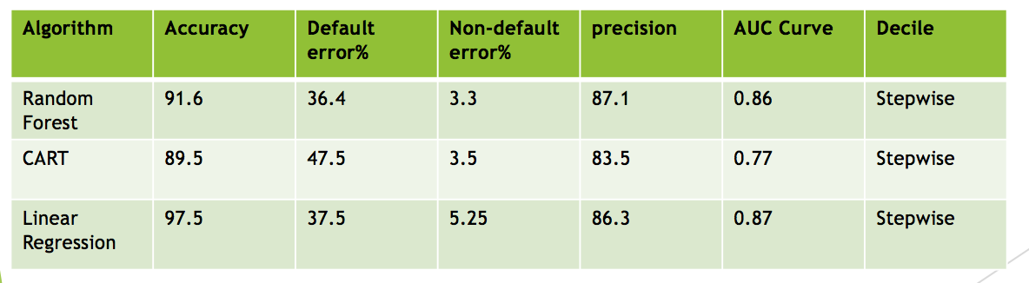

**Detecting Spam**

**Aim: Question 3**

What data mining technique(s) would be appropriate to classify whether an email is a spam or not a spam? Justify your analysis and model.

**Data set Description:**

File – Spambase.xlsx

Features – 26

Records – 4601

Response Variable – Spam

Spam has two classes. 1 – The email is spam, 0 – The email is not spam

The features in the dataset are the average count of the words which appear in an email.

**Analysis on Dataset:**

Since the features consist of words, there is no scope to explore this dataset.

Analysis was done in Tableau

1. Spam vs Non Spam – Email Count

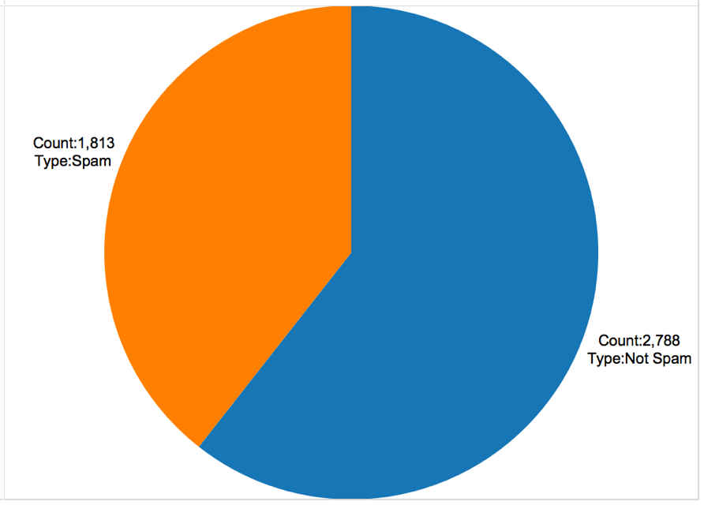

The pie chart displays the count of spam and non spam emails.

1. Spam vs Non Spam – Word List and Frequency

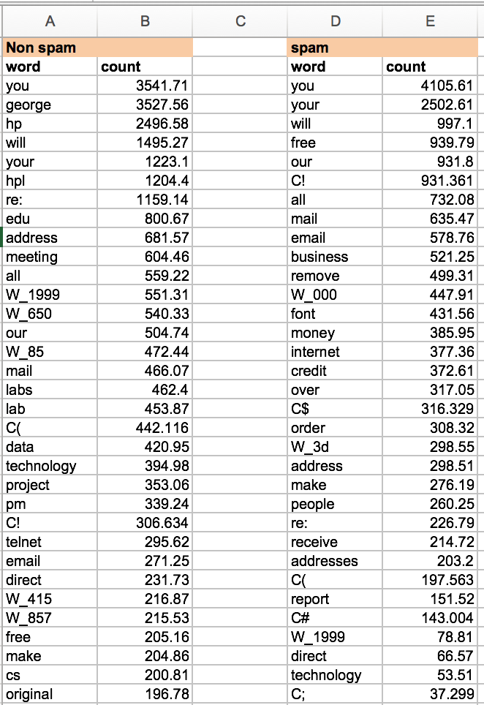

As displayed above, words and letters are categorized in two categories spam and non- spam. As seen in the real world scenario, spam emails contain words like free, business, etc. Count infers the total average occurrence of words in all the emails.

**Applied Models:**

The data was partitioned in 70(training):30(test)

After the data partition, three models were generated: -

1. CART
2. Random Forest
3. Logistic Regression

**Model Evaluation Criteria**

1. Accuracy
2. Error
3. AUC Score
4. Lift
5. Decile
6. **CART**

Confusion Matrix

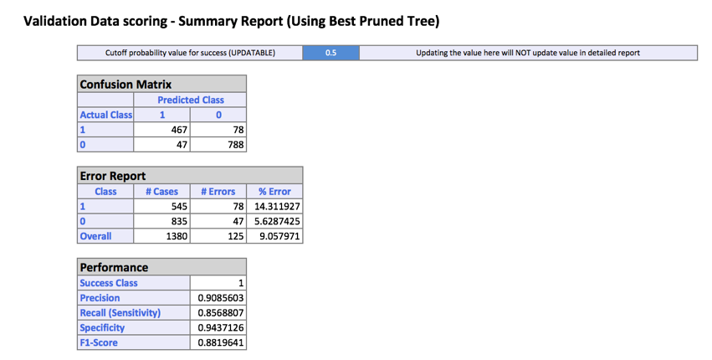

Accuracy – 88%

Precision – 90.86%

The value of precision should be higher as it implies that out of

835 non-spam emails 47 were categorized as spam.

Categorizing a non-spam mail as spam is a blunder as the user will

never get a chance to read this email.

Since 47 is a small number, CART model does a good job.

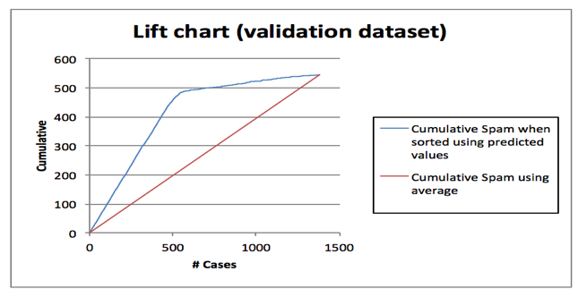AUC Score Lift Chart

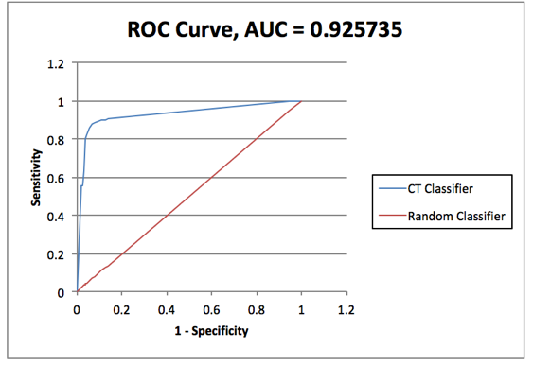

Decile

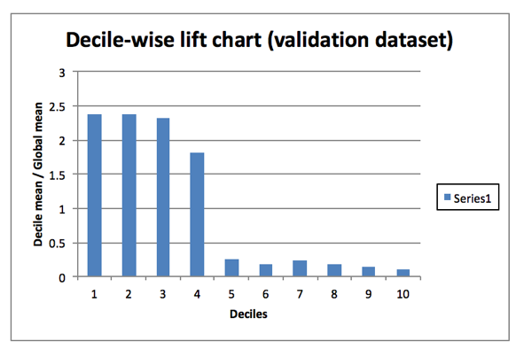

In the Lift Chart (Validating Set) pictured above, the red line originating from the origin and connecting to the point (1400, 550) is a reference line that represents the expected number of CAT MEDV predictions if XLMiner simply selected random cases (i.e., no model was used). This reference line provides a yardstick against which the user can compare the model performance.

The model (represented in blue line) is lifted by 459 / 199 = 2.31 for 500 cases from the Random

model (represented in red line). Hence the model satisfies the Lift chart

The decile-wise lift curve is drawn as the decile number versus the cumulative actual output variable value divided by the decile's mean output variable value. The above decile chart forms a stepwise pattern and hence CART model satisfies the decile chart.

ROC curves plot the performance of binary classifiers by graphing true positive rates (TPR) versus false positive rates (FPR) as the cutoff value grows from 0 to 1. The closer the curve is to the top-left corner of the graph, and the smaller the area above the curve, the better the performance of the model.

1. **Random Forest**

Confusion Matrix

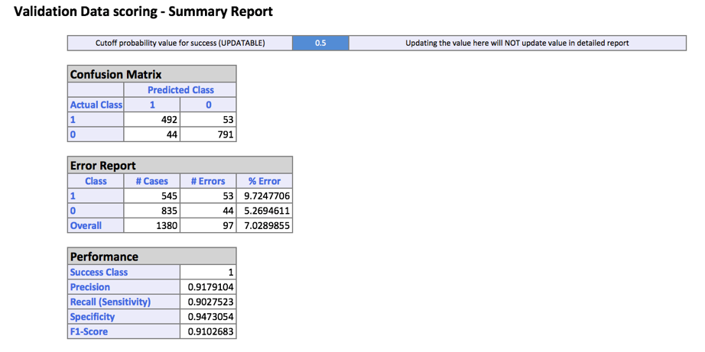

Accuracy – 91%

Precision – 91.79%

The value of precision should be higher as it implies that out of

835 non-spam emails 44 were categorized as spam.

Categorizing a non-spam mail as spam is a blunder as the user will

never get a chance to read this email.

Since 44 is a small number, Random Forest model does a good job. Better than CART.

AUC Score Lift Chart

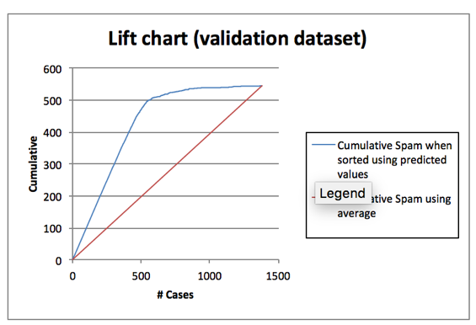

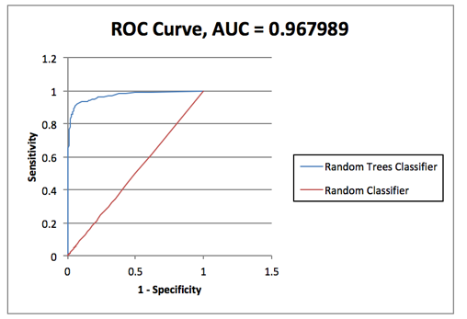

Decile

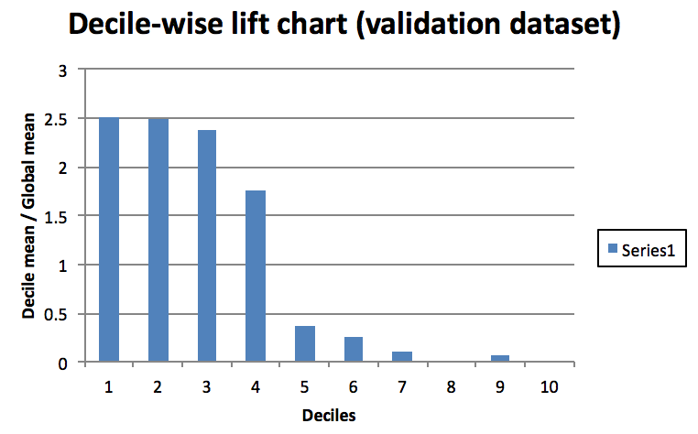

In the Lift Chart (Validating Set) pictured above, the red line originating from the origin and connecting to the point (1400, 550) is a reference line that represents the expected number of CAT MEDV predictions if XLMiner simply selected random cases (i.e., no model was used). This reference line provides a yardstick against which the user can compare the model performance.

The model (represented in blue line) is lifted by 469 / 196 = 2.39 for 500 cases from the Random

model (represented in red line). Hence the model satisfies the Lift chart

The decile-wise lift curve is drawn as the decile number versus the cumulative actual output variable value divided by the decile's mean output variable value. The above decile chart forms a stepwise pattern and hence CART model satisfies the decile chart.

ROC curves plot the performance of binary classifiers by graphing true positive rates (TPR) versus false positive rates (FPR) as the cutoff value grows from 0 to 1. The closer the curve is to the top-left corner of the graph, and the smaller the area above the curve, the better the performance of the model.

1. **Linear Regression**

Confusion Matrix



Accuracy – 91%

Presidion – 91.79%

The value of precision should be higher as it implies that out of

835 non-spam emails 47 were categorized as spam.

Categorizing a non-spam mail as spam is a blunder as the user will

never get a chance to read this email.

Since 47 is a small number, CART model does a good job.

AUC Score Lift Chart





Decile

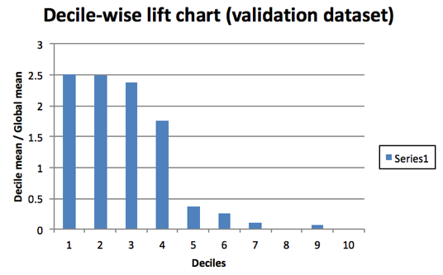

In the Lift Chart (Validating Set) pictured above, the red line originating from the origin and connecting to the point (1400, 550) is a reference line that represents the expected number of CAT MEDV predictions if XLMiner simply selected random cases (i.e., no model was used). This reference line provides a yardstick against which the user can compare the model performance.

The model (represented in blue line) is lifted by 470/198 = 2.37 for 500 cases from the Random

model (represented in red line). Hence the model satisfies the Lift chart

The decile-wise lift curve is drawn as the decile number versus the cumulative actual output variable value divided by the decile's mean output variable value. The above decile chart forms a stepwise pattern and hence CART model satisfies the decile chart.

ROC curves plot the performance of binary classifiers by graphing true positive rates (TPR) versus false positive rates (FPR) as the cutoff value grows from 0 to 1. The closer the curve is to the top-left corner of the graph, and the smaller the area above the curve, the better the performance of the model.

**Best Model**

|  |  |  |  |  |  |  |
| --- | --- | --- | --- | --- | --- | --- |
| **Algorithm** | **Accuracy** | **Error** | **Precision** | **AUC Score** | **Lift** | **Decile** |
| CART | 88.20 | 9.9 | 90.86 | 0.93 | 2.31 | Not Stepwise |
| Random Forest | 91.03 | 7.5 | 91.79 | 0.97 | 2.39 | Stepwise |
| Logistic Regression | 89.94 | 8.6 | 91.30 | 0.97 | 2.37 | Stepwise |

From the table above, Random forest has the highest precision, accuracy, AUC score and a maximum lift. Hence, model built by applying Random forest classification Algorithm over the 70% training and 30% validation data is the best model.

**If we are interested mainly in detecting spam messages, is this model useful? Use the confusion matrix, lift chart, and decile chart for the validation set for the evaluation.**

Algorithm Used – Random Forest

Confusion Matrix -

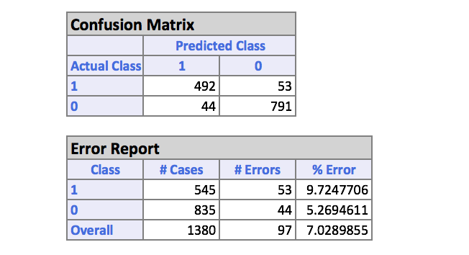

From the confusion matrix above, the error in classifying an email as spam is 9% and while Classifying an email as not spam is 5%. Since the overall error margin and the error margin between spam and not spam is narrow, the designed model is useful for spam detection.

Lift Chart –

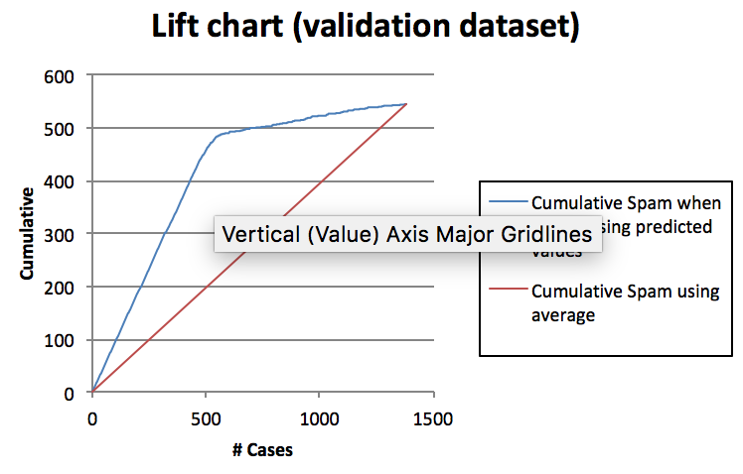

The model (represented in blue line) is lifted by 459 / 199 = 2.31 for 500 cases from the

Random model (represented in red line). Hence the model satisfies the Lift chart

Evaluation criteria.

Decile –

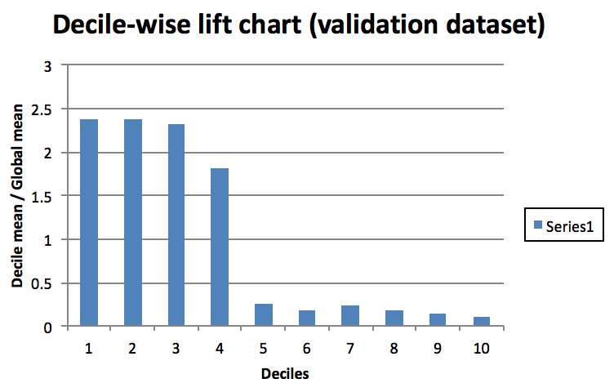

The above decile chart forms a stepwise pattern and hence model satisfies the decile chart

**Model Recommendation & Reasons:**

* Random Forest is better than CART and Logistic regression
* Random forest is the best performing model with respect to accuracy, precision, lift and decile analysis
* The model is fit to classify both the spam and non spam emails.
* The concern in this problem is to look out for emails which are not spam but marked as spam. The count of such emails should be as small as possible.

Hence Precision as criteria for evaluation is the most important parameter.

The precision is maximum for random forest. Hence there is narrow chance that the model will predict a non-spam email as spam.

**Feedback Prediction for Blog**

**Aim:**

What data mining technique(s) would be appropriate in predicting the total number of comments on blog in next 24 hours? Conduct such an analysis.

**Data set Description:**

The blog post data set provided is crawled from internet from Hungarian blog post website. The data set contains one train csv file and several other test csv files. The train csv files has around 281 columns, out of which five columns(56-60) describes the occurrence of comments before or after base time, meaning the column has the number of comments on each particular blog post before or after certain base time. The columns (1-55) are the average, min, max, standard deviation, and mean of columns 56-60. The data set contains 200 columns of high frequency random words and their count in particular blog post. We have around seven columns for weekdays from Mon to Friday indicating binary digits on which week day the post was released and another seven columns for weekdays from Mon to Friday describing binary digits for base time. We also have one column describing trackbacks in blog post.

**Analysis on Datset:**

The columns 56 to 60 are number of comments and according to base time and other factors, and we had average, min, etc. of these numbers, but our question was how is average, min, etc. is calculated because after observing the first fifty columns we found that the numbers are constant for a range and again varying for some range and so on. The assumption made for this was the columns 56-60 must be having numbers of comments for same blog post or comments for same topic of blog post and so the average is calculated for those numbers which lies in same group.

The data in train file is given for two years 2010 and 2011 and we have different test files for February and March month of 2012. We have merged the test files in four different groups one test file consisting of all data for February month only, and three files for march because we notice the pattern in naming convention of march test files that for end of march test files the files were saved with different format of 01 and rest of march files were saved with 00, so one march file consisting of entire march data set, one containing just files with 00 names and lastly one containing just 01 names files, also the reason behind doing the same, was to check the stability of model since the base time were selected randomly so there might be some overlapping in base time. If we apply model on many test files and we see stability in model for different files then model is advisable to use.

Below is the code used for merging the test files in R Studio.

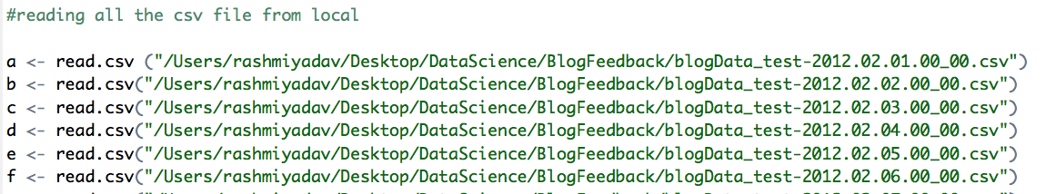

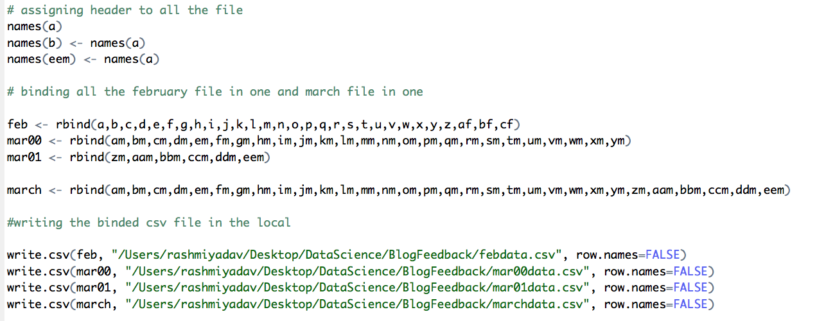

The correlation matrix describes the how input attributes are closely related to output attributes and based on this matrix we eliminated the attributes from data set in order to avoid the over fitting of model. Avoiding over fitted model is important mainly because then model gives the accuracy based on noisy data which is not good sign.

**Co-relation matrix:** The highly co related variables are shown below.

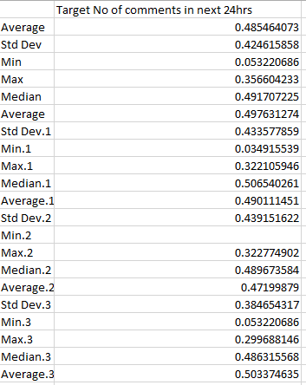 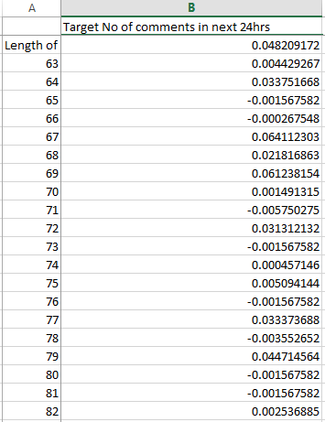

Due to large number of attributes in dataset the correlation matrix file generated is huge. To view entire matrix click here corr.csv

**Applied Models:**

* **Model 1 – Random Forest**
* **Model 2 - Cart(Decision Tree)**
* **Model 3 - Linear Regression**

**Model 1:** Performing Prediction algorithm using Random Forest algorithm for predicting the total numbers of comments in next 24 hourson train and test files of blog feedback dataset.

The parameters selected were on basis of co relation matrix. Also this problem was solved in Python. The three models were implemented in Python.

**Model score, accuracy are shown below for just February test files:**

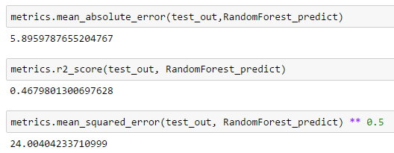

**Model score, accuracy are shown below for just March(All) test files:**

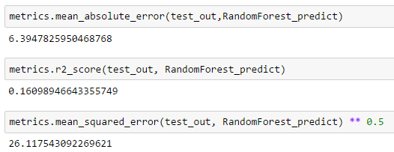

**Model score, accuracy are shown below for just March(00) test files:**

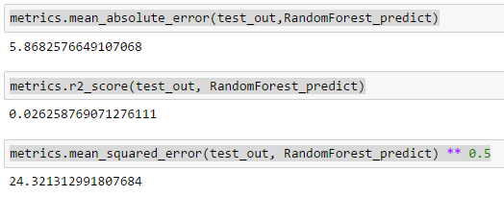

**Model score, accuracy are shown below for just March(01) test files:**

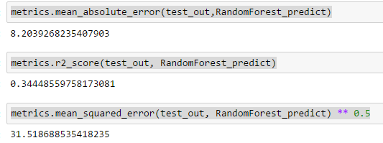

**Model 2 CART:** Performing Prediction algorithm using CART algorithm for predicting the total numbers of comments in next 24 hourson train and test files of blog feedback dataset.

The parameters selected were on basis of co relation matrix.

**Model score, accuracy are shown below for just February test files:**

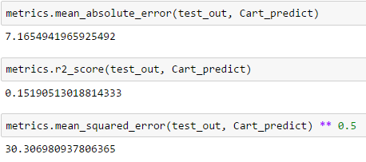

**Model score, accuracy are shown below for just March(All) test files:**

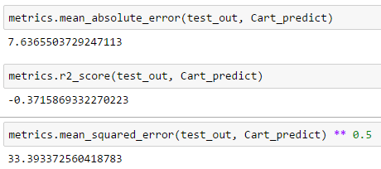

**Model score, accuracy are shown below for just March(00) test files:**

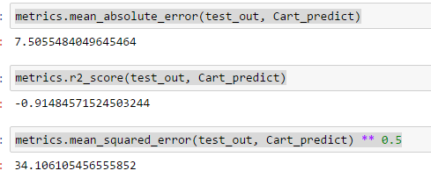

**Model score, accuracy are shown below for just March(01) test files:**

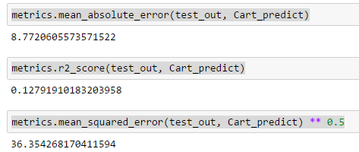

**Model 3 Linear Regression:** Performing Prediction algorithm using Linear Regression algorithm for predicting the total numbers of comments in next 24 hourson train and test files of blog feedback dataset.

The parameters selected were on basis of co relation matrix.

**Model score, accuracy is shown below for just February test files:**

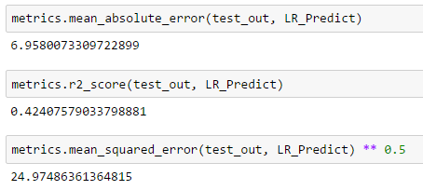

**Model score, accuracy is shown below for just March(All) test files:**

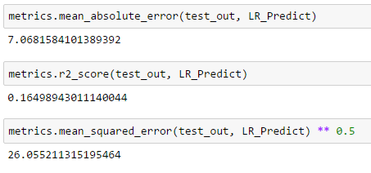

**Model score, accuracy are shown below for just March(00) test files:**

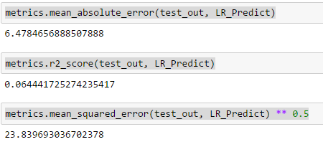

**Model score, accuracy are shown below for just March (01)test files:**

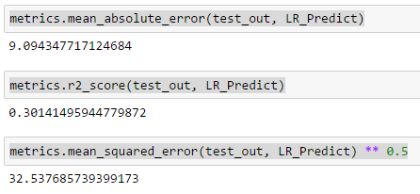

**Model Recommendation & Reasons:**

* Random Forest model works very well compared to Cart and Linear Regression.
* Also Random Forest Model most stable model amongst three
* Random Forest model has less root mean square error than cart and Linear Regression, which tells that on predicted values random forest has less probability of error
* Not just accuracy of any model is important factor while deciding whether model is good or bad, the stability of model matter’s the most.